Admin Dashboard.

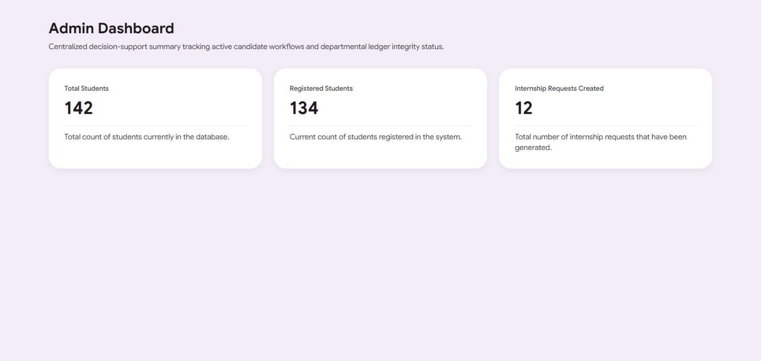

Simple Page Structure Description
- Page Title / Metadata: Sets up the administrative portal environment under the official title "Admin Dashboard Content | CV Management & Filtering System".
- Main Container Wrapper: A singular structural layout boundary constrained to a maximum desktop framework width of 1340px to maintain visual consistency across wide displays.
- Dashboard Header Block: The primary informational introduction housing a bold workspace title ("Admin Dashboard") and a descriptive paragraph outlining the decision-support system.
- High-Priority Metrics Grid: A responsive three-column grid component configured to partition system tracking data side-by-side, collapsing safely into stacked blocks on compact mobile viewports.
- Total Students Summary Card: A dedicated data enclosure presenting the exact count of student records currently initialized in the platform database.
- Registered Students Summary Card: A structural panel displaying the real-time volume of verified student profiles registered within the active directory.
- Internship Requests Summary Card: A final metrics panel displaying the total cumulative number of internship placement requests generated by the system.

Main functionalities available to Admin on this page :

• View Total Student Volume: The administrator can view a high-level metric card displaying the static total count of students currently residing inside the database (valued at 142).
• Monitor Registered Profile Counts: The administrator can read a summary card tracking the active number of students successfully registered within the platform's system directory (valued at 134).
• Track Cumulative Internship Requests: The administrator can view a performance metric displaying the total number of internship placement requests that have been generated by the system (valued at 12).
• Review Portal Context: The administrator can read the centralized header text outlining that the workspace tracks active candidate workflows and departmental ledger integrity statuses.

Let’s move to the Admin login page.

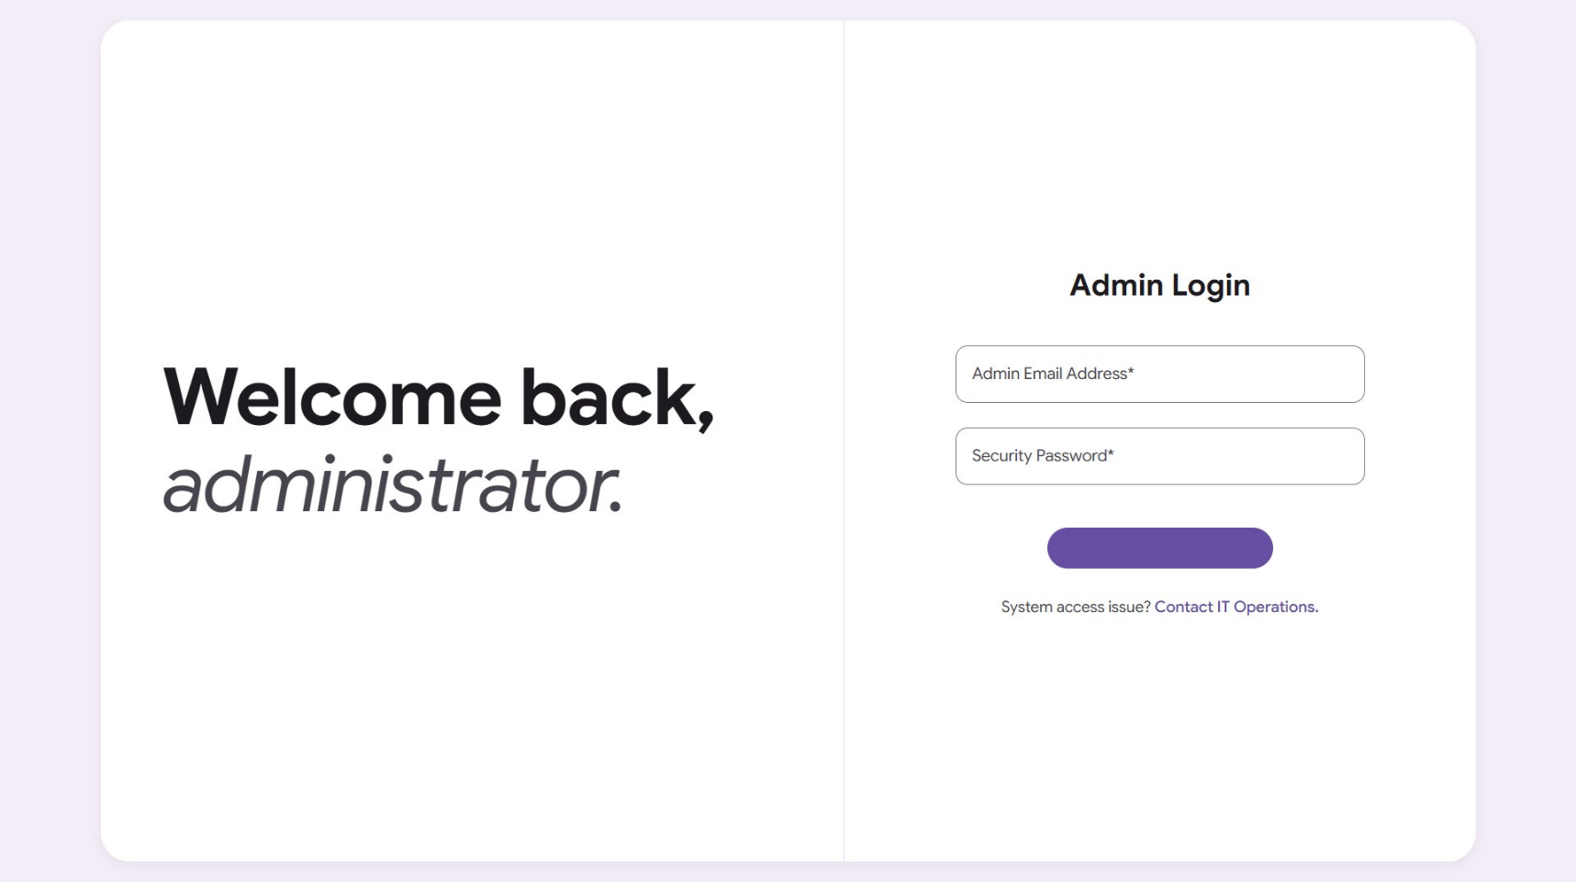

Simple Page Structure Description
- Page Title / Metadata: Sets up the secure administrative portal environment under the official title "Admin Sign-In | CV Management System".
- Asymmetrical Split Container: A structural layout framework built to a maximum width constraint of 1340px that divides the layout into two primary columns, which dynamically folds into a single stacked column configuration on mobile viewports.
- Welcome Panel (Left Column): A typography-focused presentation canvas designed to greet users, containing a large, high-contrast headline reading "Welcome back, administrator."
- Administrative Workspace (Right Column): The main interaction zone holding the system authentication card and form elements:
  - A centered section header identifying the workflow space as "Admin Login".
  - Two stacked Material Design 3 outlined text inputs mapped out to capture the operator's "Admin Email Address" and "Security Password" credentials.
  - A primary, bottom-centered Material Design 3 filled button designed for system entry labeled "Log In".
  - A helpful system routing footer line that redirects operators facing login complications to contact IT Operations.

Main functionalities avaialble to admin on this page :

• Enter Identity Credentials: The administrator can type their unique username or system email address into the designated text input field.
• Input Security Password: The administrator can input their confidential security password into a protected, masked text field.
• Submit Authentication Requests: The administrator can click or trigger the primary "Log In" button to submit their credentials for system validation.
• Access Technical Support Support Links: If experiencing platform access complications, the operator can click the integrated support hyperlink to navigate away to the IT Operations contact portal.

And let’s move to Students Academic Records Ledger page.
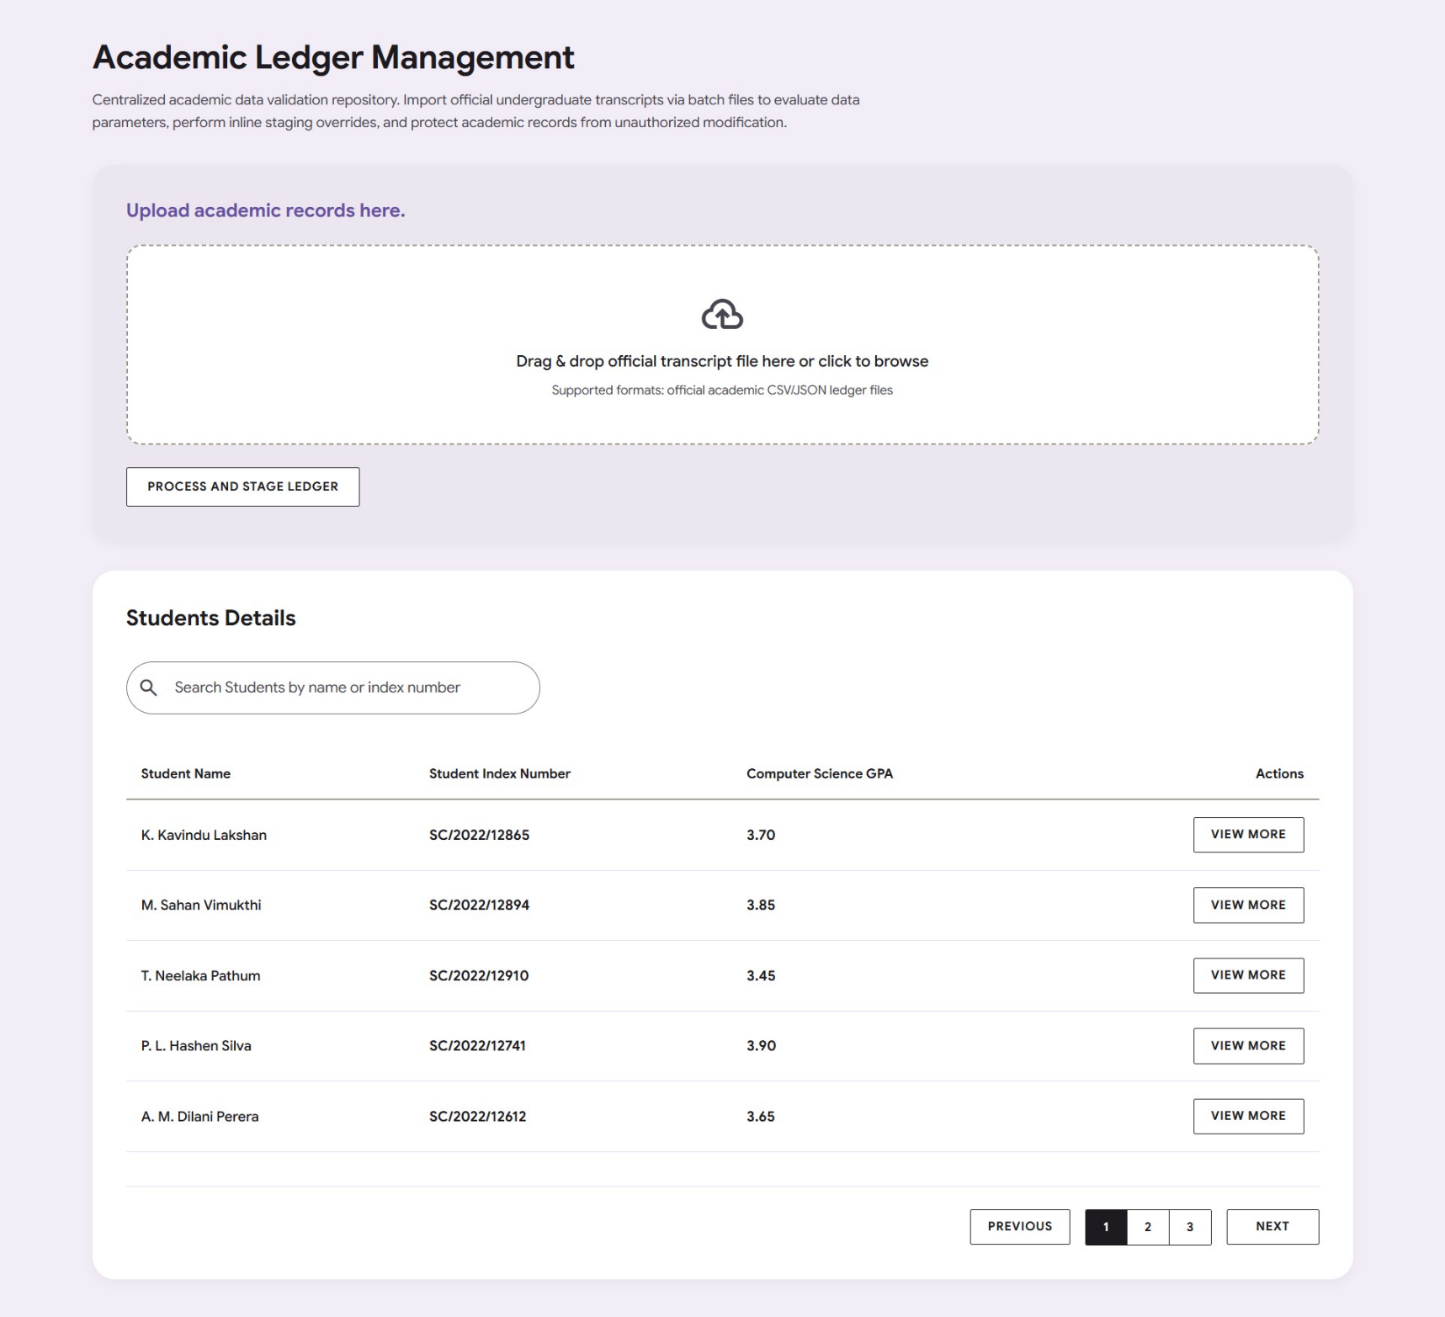

Student Academic Records Detailed View
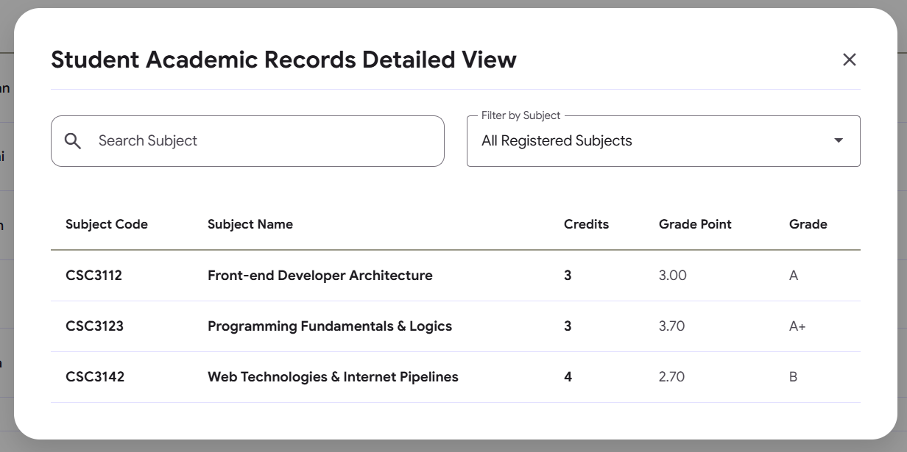

Simple Page Structure Description
- Page Title / Metadata: Sets up the administrative verification portal under the official title "Academic Ledger Management | CV Management & Filtering System".
- Main Container Wrapper: A primary layout canvas constrained to a maximum framework alignment width of 1340px to ensure structural balance on high-resolution viewports.
- Page Header Block: An introductory workspace section housing an authoritative page title ("Academic Ledger Management") and a functional paragraph defining the transcript validation repository rules.
- Upload Records Section (Light Panel Card): A stylized ingestion panel containing:
  - A prominent section header reading "Upload academic records here."
  - A central dashed interactive dropzone built to receive or browse official ledger datasets.
  - An action button to initiate background calculations labeled "Process and Stage Ledger".
- Student Details Section (Canvas Panel Card): A high-contrast ledger directory workspace that anchors the primary user controls, encompassing:
  - A section header labeling the data collection as "Students Details".
  - A compact search field layout built to target candidate queries by name or index number.
  - A responsive database matrix sorting registered cohort columns by Student Name, Student Index Number, and Computer Science GPA.
  - A vertical row alignment of "View More" uppercase target trigger buttons.
  - A bottom-centered micro-pagination navigation bar framing page indexes between "Previous" and "Next" action selections.
- Detailed View Overlay Modal: A dark-shield center-stage pop-up window configured to show granular subject records, containing:
  - A header zone displaying the title "Student Academic Records Detailed View" next to a close button control.
  - A side-by-side symmetric row configuration combining a subject query search field and a dropdown selection filter menu.
  - A clean, dense tabular grid tracking individual candidate scores across Subject Code, Subject Name, Credits, Grade Point, and Grade.

Main functionalities avaialble to admin on this page :
1. Transcript Ingestion & Staging
- Select Academic Batch Files: Admins can drag and drop or click to browse and select official student academic files in CSV or JSON formats using the dedicated uploader dropzone.
- Process and Stage Records: Admins can trigger the "Process and Stage Ledger" button to ingest the selected dataset, allowing them to review and evaluate the academic data parameters before final database integration.
2. Student Directory Exploration
- Query the Registry: Admins can filter down the student details table in real-time by typing a student's name or unique index number into the leading-icon search field.
- Scan High-Level Performance Metrics: The main interface table allows admins to immediately review core identity records alongside specific computed parameters like the Computer Science GPA.
- Navigate Dense Directories: Admins can click the "Previous" and "Next" layout buttons or choose explicit page index blocks within the pagination row to cycle through different segments of the student directory.
3. Detailed Academic Review (Modal Overlay)
- Launch Granular Progress Profiles: Clicking the "View More" action button on a specific student's row dynamically launches a centered center-stage modal card containing that student's complete academic portfolio.
- Search Specific Course Subsets: Inside the modal profile, admins can look up specific subjects by typing course terms into the "Search Subject" field.
- Isolate Curriculums via Dropdown Filters: Admins can selectively filter the modular grade matrix using a dropdown menu configured to isolate course configurations like Front-end Developer Architecture, Programming Fundamentals & Logics, or Web Technologies & Internet Pipelines.
- Audit Line-Item Grades: The detailed tabular grid provides direct transparency, allowing the administrator to inspect individual Subject Codes, subject titles, credit weights, exact Grade Points, and final alphabetical letters.
- Dismiss Detailed Profiles: Admins can exit the overlay workspace and return to the main database directory at any time by clicking the dedicated close text icon or tapping the dimmed exterior viewport shield.

Let’s move to Students List page.
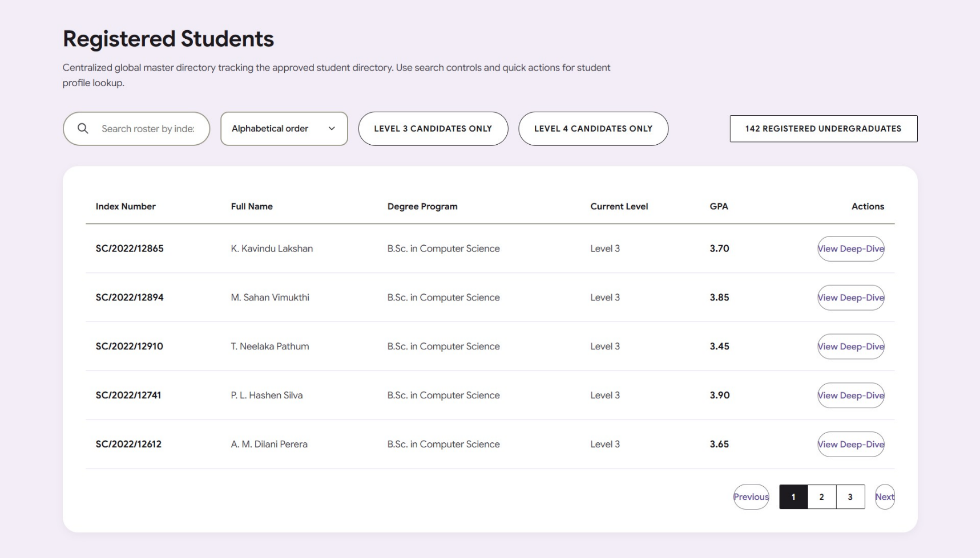

Simple Page Structure Description
- Page Title / Metadata: Sets up the administrative student roster directory environment under the official title "Registered Students | CV Management & Filtering System".
- Main Container Wrapper: A primary application framework constrained to a maximum centered boundary width of 1340px to maintain technical line and layout integrity on wide-screen displays.
- Page Header Block: An introductory component containing an authoritative layout title ("Registered Students") and a multi-line descriptive text overview explaining the system's global tracking utilities.
- Utility Control Toolbar: A multi-component row configured to filter database parameters cleanly before data rendering, containing:
  - A pill-shaped active search block embedded with a vector magnifying icon to target candidates by name, index, or cohort batch.
  - An architectural sorting dropdown menu offering predefined classification filters (Alphabetical, GPA scales, or Index tracking orders).
  - Two inline interactive quick filter chips used to instantly isolate Level 3 or Level 4 undergraduate candidate profiles.
  - A high-contrast global tracking roster badge displaying the fixed directory capacity ("142 Registered Undergraduates").
- Master Card Enclosure Section: A primary white M3 container section designed to group tabular data and structural navigation anchors tightly.
- Responsive Roster Table: A robust, wide-scrolling informational grid displaying candidate profiles across six descriptive system columns: Index Number, Full Name, Degree Program, Current Level, GPA, and Actions.
- Action Triggers: A column section holding individual, highly breathable Material Design 3 outlined button elements custom-labeled "View Deep-Dive".
- Basal Pagination Component: A bottom-aligned control frame that regulates directory page cycles using two Material Design 3 buttons ("Previous" and "Next") wrapped around a set of numeric indicator tiles.

Main functionalities avaialble to admin on this page :

1. Searching & Filtering
- Search the Directory: Admins can look up specific student records by typing an index number, full name, or batch year into the text input search field.
- Filter by Academic Level: Admins can toggle interactive filter chips to isolate and view only "Level 3 Candidates Only" or "Level 4 Candidates Only". The embedded JavaScript ensures these selections are mutually exclusive (selecting one clears the other).
2. Sorting Records
- Reorder the Dataset: Admins can change the display order of the student list using the dropdown menu. The available sorting criteria are:
  - Alphabetical order
  - GPA (High to Low)
  - GPA (Low to High)
  - Index Number order
3. Data Viewing & Roster Auditing
- Monitor Enrollment Totals: Admins can instantly verify the overall directory capacity via a dedicated tracking badge displaying the text "142 Registered Undergraduates".
- Audit High-Level Student Profiles: The tabular grid allows admins to scan and review critical data points for each student, including their Index Number, Full Name, Degree Program, Current Level, and official GPA.
4. Interactive Navigation & Entry Actions
- View Detailed Analytics ("Deep-Dive"): Admins can click the Material Design 3 View Deep-Dive button located on any student's row to initiate a deep-dive look into that specific individual's file.
- Paginate through Roster Pages: Admins can use the micro-pagination layout at the bottom to navigate through large student lists by clicking the Previous or Next buttons, or by selecting explicit page number blocks (e.g., 1, 2, or 3).

Let’s move to Students Deep dive page.

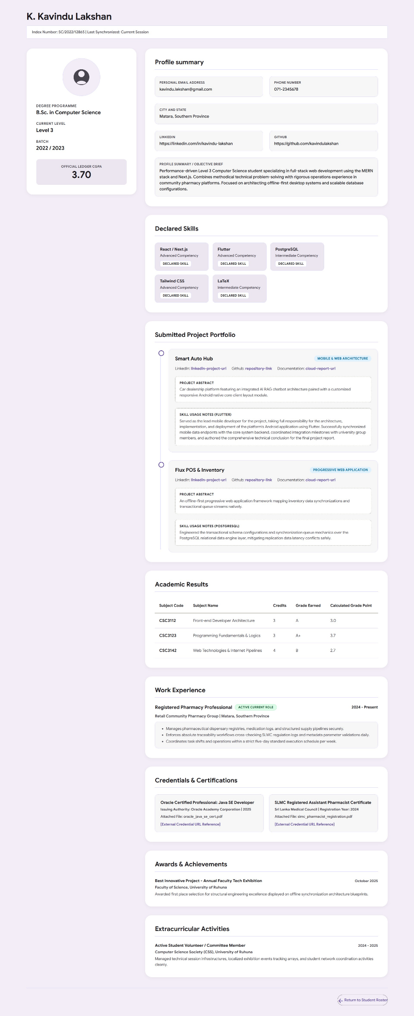
Simple Page Structure Description
- Page Title / Metadata: Sets up the administrative student audit environment under the official title "Student Details Deep-Dive | Administrative Inspection Suite".
- Main Container Wrapper: A primary layout boundary constrained to a maximum framework width of 1340px that handles the vertical alignment of all sub-components.
- Global Header Block: Houses the student's full name as an authoritative section title and provides a metadata status tracking bar displaying the candidate's index number and synchronization state.
- Asymmetric presentation split matrix: A main content grid dividing the screen layout into a narrow left-hand anchor pane (1fr) and a spacious right-hand portfolio column (2.2fr), adapting seamlessly to a single stacked row on smaller devices.
- Institutional Anchor Panel (Left Column): A sticky layout block housing core tracking identifiers:
  - An ATS-resilient circular vector container placeholder for student profile imagery.
  - A read-only typography block documenting student enrollment parameters (Degree Programme, Current Level, and Batch).
  - A high-contrast, locked data badge showcasing the official compiled cumulative GPA tracking asset.
- Comprehensive Portfolio Stack (Right Column): A vertical stack of distinct Material Design 3 section cards tracking individual verification blocks:
  - Profile summary: A multi-column read-only interface grid detailing email contact lines, phone networks, localized geographies, digital portfolio URLs, and an objective brief paragraph.
  - Declared Skills: A flex-wrapping matrix organizing individual technical skill cards cleanly stripped of voluntary color highlighting rules.
  - Submitted Project Portfolio: A timeline-driven layout detailing past student system architectures with individual abstracts, source code references, and skill application notes.
  - Academic Results: A wide-scrolling information matrix compiling certified module credits, grade metrics, and individual computed grade points.
  - Work Experience: A timeline-based professional history array formatting previous employments, active position capsules, and bulleted task lists.
  - Credentials & Certifications: A sub-grid network displaying professional engineering certificates and digital confirmation link paths.
  - Awards & Achievements: An isolated text box documenting formal faculty exhibition prizes, dates, and rewarding bodies.
  - Extracurricular Activities: A final standalone section logging volunteer initiatives, student society roles, and institutional responsibilities.
- Persistent Utility Footer: A boundary line anchor at the base of the page containing a right-aligned, highly breathable Material Design 3 outlined button labeled "Return to Students list".

Main functionalities avaialble to admin on this page :

- Inspect Core Identity and Institutional Tracking Metadata:
  - The admin can review the student's full name, index number, and session synchronization state.
  - The admin can verify specific educational tracks including the degree programme, current academic level, and enrollment batch.
  - The admin can view the definitive, hard-locked cumulative ledger CGPA display.
- Audit Profile Summaries and Verified Contact Nodes:
  - The admin can evaluate private communication lines including personal email addresses, phone contacts, and physical geography entries.
  - The admin can click out to inspect external networking profiles via raw LinkedIn and GitHub link blocks.
  - The admin can read through the comprehensive background objective brief narrative.
- Review Technical Competencies and Skill Arrays:
  - The admin can scan individual skill inventory badges detailing technical competencies.
  - The admin can confirm individual skill tiers alongside their declaration verification statuses.
- Examine Project Portfolios and Evidence Evidence Proofs:
  - The admin can trace structural project timelines detailing development platforms and development types.
  - The admin can click integrated anchor links to view source code repositories, linked external platforms, and cloud report files.
  - The admin can read complete project abstracts and specific skill usage case notes detailing student contributions.
- Audit Academic Performance Records:
  - The admin can evaluate wide-scrolling results tables tracking student history by subject code and full subject names.
  - The admin can verify categorical unit parameters including class credits, letter grades earned, and calculated grade points.
- Trace Professional Experience Timelines:
  - The admin can inspect industry history lines highlighting active employment roles, company names, and regional operational locations.
  - The admin can audit bulleted duty summaries detailing the standard operational workflows and regulatory frameworks managed by the student.
- Verify Professional Credentials and Certificates:
  - The admin can look over external professional certificates, issuing corporate bodies, and registration years.
  - The admin can inspect specific filenames for attached documents and access verification links via external URL references.
- Review Accolades and Extracurricular Initiatives:
  - The admin can inspect achievement rows highlighting tech exhibition placement awards, dates, hosting institutions, and structural blueprint summaries.
  - The admin can review historical student society roles, technical infrastructure volunteer workloads, and coordination timeline histories.
- Navigate Workspace Pathways:
  - The admin can interact with the responsive Material Design 3 footer action control button to cleanly exit the deep-dive panel and return directly back to the primary student list.
Let’s move to Internship Management page.
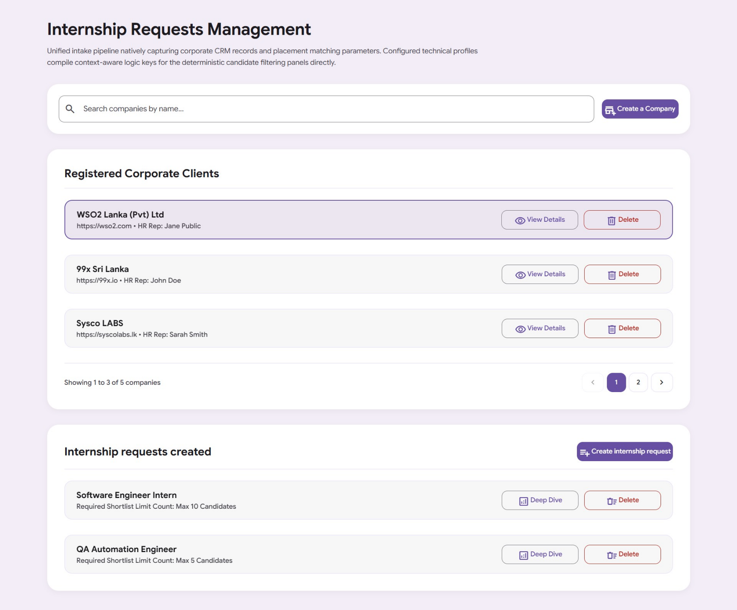

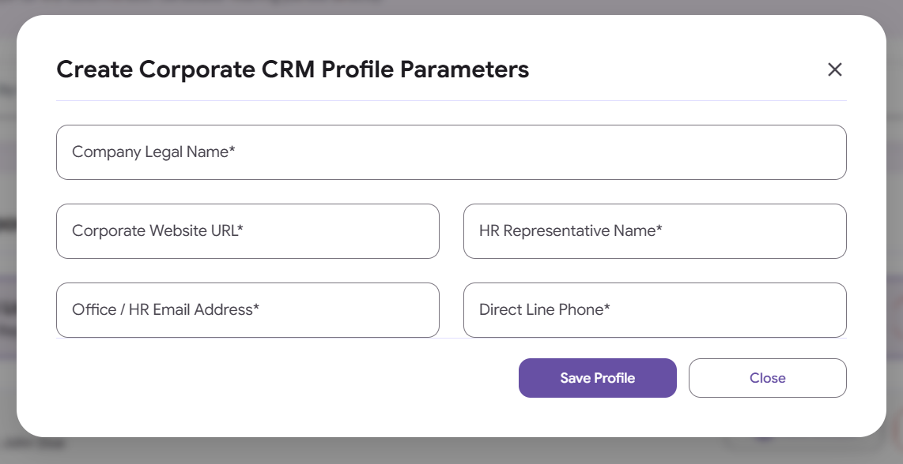

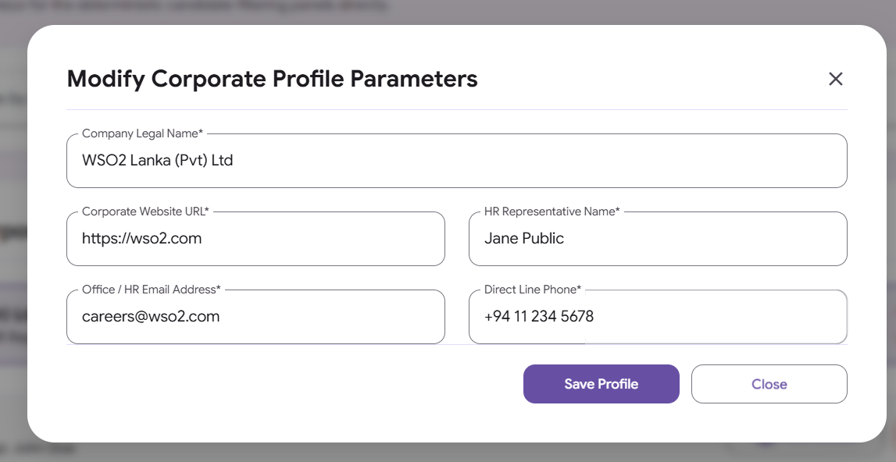

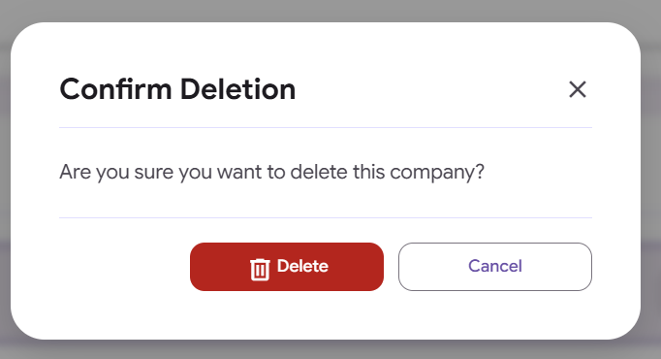

Simple Page Structure Description
- Page Title / Metadata: Sets up the administrative recruitment portal environment under the official workspace title "Internship Requests Management | CV Management & Filtering System".
- Main Container Wrapper: A primary layout boundary locked to a maximum structural framework width of 1340px to maintain clean visual line alignment across wide desktop screens.
- Page Header Block: An introductory component containing an authoritative workspace heading ("Internship Requests Management") and a descriptive paragraph defining the scope of the intake pipeline.
- Search & Action Toolbar Row: A horizontal layout section that groups global corporate tools side-by-side, containing a company search field with an embedded vector icon and a primary "Create a Company" action button.
- Registered Corporate Clients Card Section: A large white Material Design 3 container card that displays the client database list layout, individual data meta-rows, row-level view and delete button elements, and a dedicated micro-pagination navigation toolbar.
- Internship Requests Card Section: A secondary Material Design 3 container card holding a section header title, a "Create internship request" action trigger button, and a reactive status container designed to show detailed interactive rows or placeholder instructions.
- Corporate Profile Modal Overlay: A hardware-accelerated fullscreen popup window enclosing a profile card form layout with five text entry fields (Company Legal Name, Corporate Website URL, HR Representative Name, Office / HR Email Address, and Direct Line Phone) capped by bottom action triggers and a top-right close handle.
- Candidate Selection Modal Overlay: A center-stage overlay configuration structured to process placement parameters, holding inputs for Role Title and Shortlist Limits, cascading cluster and category select drop menus, an autocomplete taxonomy field, a flex-wrapping skill token array, and an active confirmation button.
- Delete Confirmation Modal: A high-priority standalone overlay dialog window designed to safeguard database records by demanding explicit operator confirmation before executing a deletion command.

Main functionalities avaialble to admin on this page :

Based on the provided code for the Internship Requests Management page (admin.html), an administrator can perform full CRUD (Create, Read, Update, Delete) workflows to manage corporate client entries and their linked placement requirements.
The exact functionalities available on this page are organized below by workspace modules:
1. Corporate CRM & Company Management (CRUD Framework)
- Search Companies: The admin can filter through the registered client records by typing query strings directly into the company name search bar.
- Paginate Corporate Directory: The admin can browse through paginated blocks of companies (configured to 3 records per page) using the "Previous", "Next", or explicit numeric page selection controls.
- Select Active Corporate Profile: Clicking on any company item row selects that profile, applies a custom visual active outline, and dynamically populates its child internship requests.
- Create a New Company: The admin can click the "Create a Company" button to launch the "Corporate CRM Profile Parameters" modal form to append a new client entity. The fields captured include:
  - Company Legal Name
  - Corporate Website URL
  - HR Representative Name
  - Office / HR Email Address
  - Direct Line Phone
- View Company Details: Clicking "View Details" on a company item opens the CRM modal in a locked, read-only mode to safely audit all stored data fields.
- Edit Corporate Profile: While viewing a company's details modal, the administrator can tap the "Edit" trigger to make the input text fields editable and save updates into memory.
- Delete a Company: The admin can click the row-level "Delete" button to wipe out a corporate account. This action automatically prompts a secondary confirmation dialog modal to safeguard against accidental clicks and erases both the company profile and all its child requirements from the database memory state.
2. Internship Requests Workflow Management (CRUD Framework)
- Explore Associated Requests: Once an active client profile is chosen, the admin can inspect all existing internship requests generated under that specific company name under the section "Internship requests created".
- Create an Internship Request: Clicking the "Create internship request" button opens the "Candidate Selection Criteria" overlay modal to attach a new vacancy blueprint.
- Leverage the Hierarchical Skills Taxonomy Mapping Engine: Within the selection modal, the admin can build out the criteria matrix using the following filters:
  - Select a target Level 1 Core Cluster (e.g., Core Engineering, Data & Infrastructure, etc.).
  - Select a cascading Level 2 Core Category which unlocks dynamically based on the parent cluster.
  - Type into the context-aware skills autocomplete input bar to search for programmatic competencies.
  - Map technical parameters by clicking on a suggestion item to instantly generate an absolute, pop-animated skill token bubble.
  - Dismiss unnecessary requirement flags by clicking the close cross (×) icon on any active skill token.
- Examine Request Details ("Deep Dive"): The admin can click the "Deep Dive" button on any active requirement row to launch the candidate selection modal in an immutable view state, letting them inspect the role title, shortlist limits, and compiled competency strings.
- Edit Placement Criteria Settings: Tapping the internal "Edit" anchor on the request modal opens the specification rules, letting the operator fine-tune shortlist capacities or append and remove skill token array sets.
- Delete an Internship Request: Tapping the row-level request delete icon opens the deletion validation prompt window, letting the operator permanently clear that standalone requirement model from the workflow.
3. Integrated Form Validation & Safety Safeguards
- Enforce Skill Token Verification Constraints: Built-in validation blocks prevent admins from saving blank request matrices. The system triggers a browser alert flag and halts form submission if an operator tries to commit a request profile that doesn't hold at least one valid competency token.
- Secure Deletion Fail-Safes: All critical database removal targets pass through a centralized confirmation window modal ("Confirm Deletion"), giving the administrator an interface step to explicitly verify or cancel high-consequence database actions before execution.

Lets move to the Candidate Filtering Panel page.

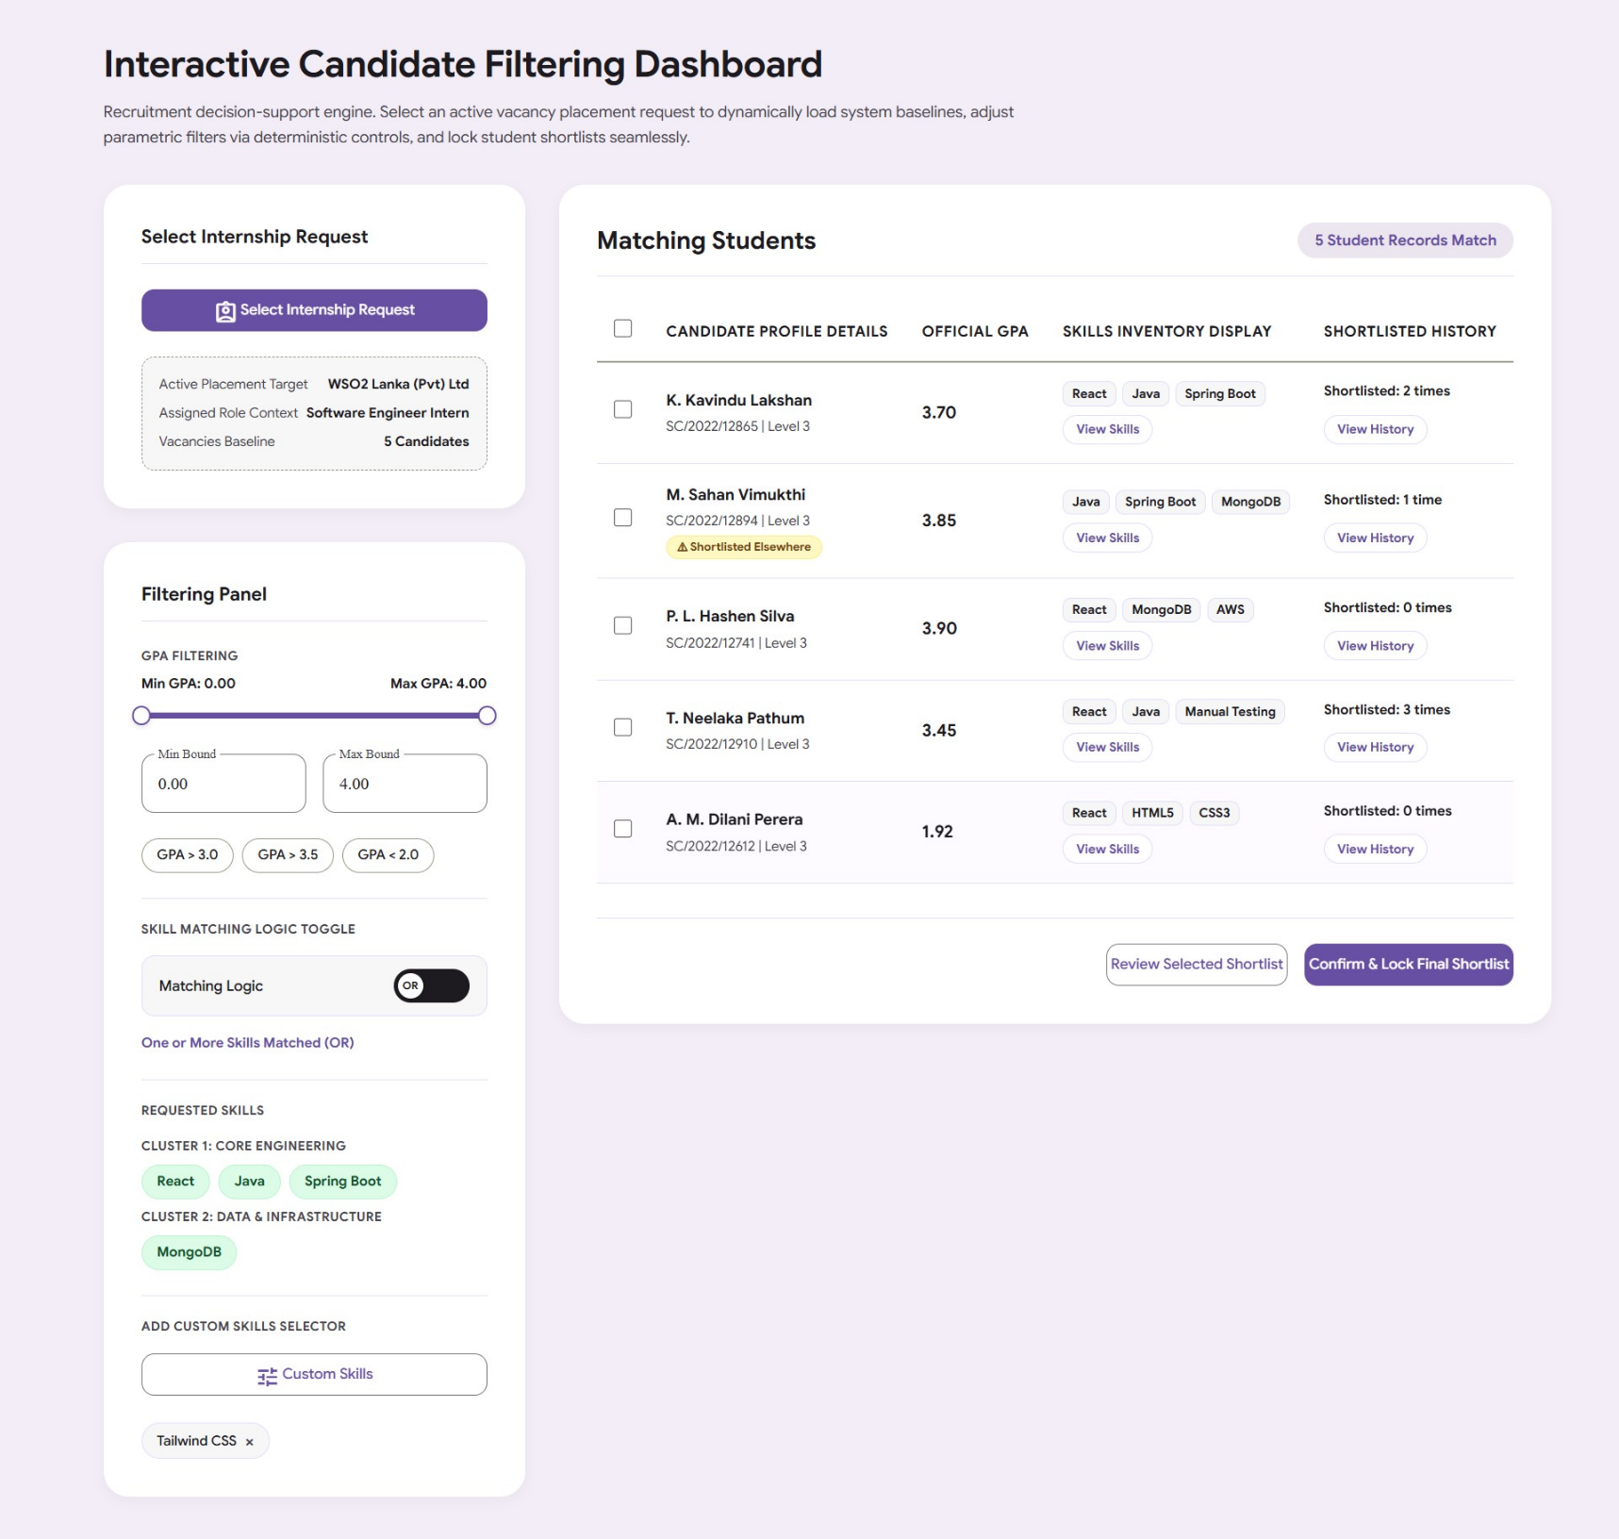

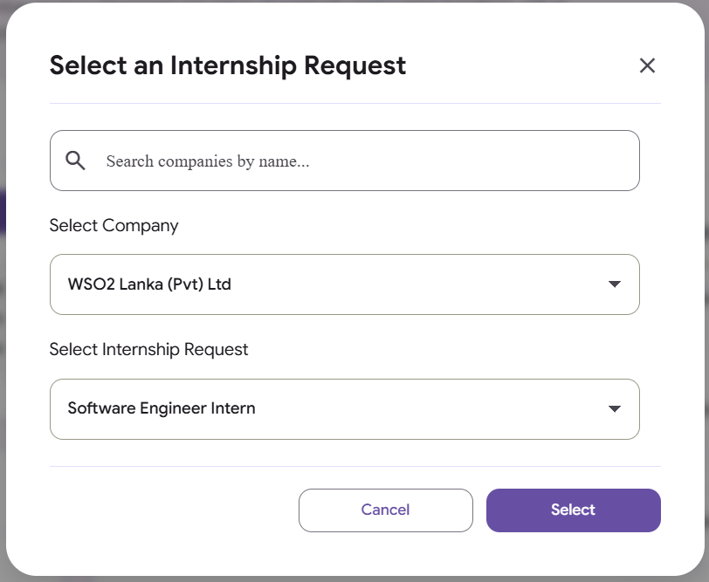

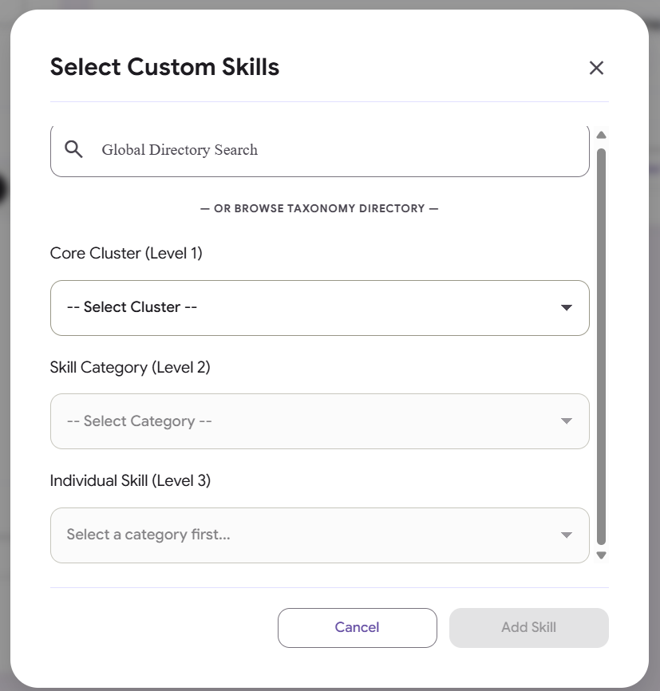

Simple Page Structure Description
- Page Title / Metadata: Configures the administrative selection ecosystem under the official browser title "Interactive Candidate Filtering Dashboard | Ruhuna CS CV Management System".
- Main Container Wrapper: A global design layout container limited to a maximum framework alignment width of 1340px to maintain strict structural continuity across wide-screen desktop displays.
- Dashboard Header Block: An introductory workspace layout zone holding an authoritative section title ("Interactive Candidate Filtering Dashboard") and a multi-line paragraph explaining the recruitment support engine.
- Asymmetric Split-Pane Layout Grid: A robust multi-column dashboard grid that partitions user controls into a locked left-hand parameter sidebar (400px) and a wide right-hand live streaming data canvas (1fr).
- Internship Request Selection Workspace (Sidebar Card 1): A dedicated white container card built to load systemic baselines, containing:
  - A primary action button labeled "Select Internship Request".
  - A dashed context-aware summary box that displays read-only data strings for the Active Placement Target, Assigned Role Context, and Vacancies Baseline.
- Parametric Filtering Panel (Sidebar Card 2): A dense administrative control block grouping deterministic search filters together, which includes:
  - A dual-handle range slider track for minimum and maximum GPA selections accompanied by a row of hard bounding numerical inputs (Min Bound and Max Bound).
  - A row layout containing three pre-set fast action capsule filter chips (GPA > 3.0, GPA > 3.5, and GPA < 2.0).
  - A horizontal section divider holding an interactive boolean logic toggle switch to alternate system calculations between OR and AND matching constraints.
  - A dynamic layout zone that automatically maps out a request's baseline mandatory skills.
  - A custom action trigger button labeled "Custom Skills" that anchors a dedicated drop layer row for user-defined capsule chips.
- Live Streaming Results Canvas (Right Column Card): A large white M3 container card designed to refresh search queries instantly, housing:
  - A streamlined counter bar combining a section title ("Matching Students") with an uppercase results count tracking badge.
  - A high-contrast, wide-scrolling database matrix utilizing a master checklist selection box sorted across five distinct columns: Checkbox, Candidate Profile Details, Official GPA, Skills Inventory Display, and Shortlisted History.
  - Individual row elements framing candidate hyperlink names, index numbers, multi-line evaluation warnings, and clickable mini-capsule cells ("View Skills" and "View History").
  - A bottom-aligned global action bar showcasing two highly breathable, balanced finalization buttons labeled "Review Selected Shortlist" and "Confirm & Lock Final Shortlist".
- Overlay Modals System Framework: A collection of four standalone window overlays built with secure blur backdrops and right-angled close handles to safely handle complex workflow configurations:
  - Internship Request Modal: Encloses a search filter box and cascading select menus used to isolate valid corporate profile vacancy models.
  - Custom Skills Modal: Combines a global directory autocomplete query input, a hidden suggestions dropdown box, and a 3-level cascading menu tree (Cluster, Category, and Skill) to safely inject new parameters.
  - Student Skills Modal: Generates a structured view displaying a student's full verified competency profile categorized cleanly by hierarchy.
  - Student History Modal: Houses a ledger details table tracking past candidate placement records across different companies and roles.

What functionalities that admin can do in this page.

### 1. Placement Context Intake & Selection

* **Select an Active Internship Request:** The administrator can launch a specialized context overlay modal by clicking the "Select Internship Request" sidebar button.
* **Filter Corporate Profiles inside Modal:** Within the request intake overlay, the administrator can perform text searches using a name search field to rapidly narrow down company dropdown lists.
* **Utilize Cascading Menu Options:** Selecting a client company via the primary select menu dynamically unlocks and cascadingly populates the sub-menu options with that company's specific active internship vacancy requirements.
* **Audit Baseline Metrics:** After selecting a placement request, the sidebar summary block automatically displays the active corporate client target name, assigned position title, and the maximum vacancy budget capacity constraints.

### 2. Parametric Candidate Query Engineering (Filtering Controls)

* **Adjust GPA Threshold Boundaries:** The administrator can fine-tune target candidate grade scales using two synchronized filtering methods:
* Interacting with a dual-handle visual range track slider.
* Typing specific minimum or maximum limits directly into the hard numeric bounding input fields, which automatically update the slider positions.

* **Apply Fast Action GPA Presets:** Admins can click preset filter chips to instantly toggle specific GPA criteria bands (`GPA > 3.0`, `GPA > 3.5`, or `GPA < 2.0`).
* **Alternate Skill-Matching Logic Toggles:** Admins can interact with a boolean switch component to alter the background filter calculus between two distinct logical operators:
* **Inclusive Mode (OR):** Matches students who possess *one or more* of the selected skills.
* **Strict Mode (AND):** Mandates that matching students must possess *all* selected programmatic competencies simultaneously.

* **Modify Baseline Requested Skills Requirements:** The administrator can selectively click on the baseline skills filter chips generated for the active internship role to individually switch them between active (green) and inactive states, recalculating results immediately.
* **Search and Inject Custom Skills Parameters:** Admins can expand filtering matrices by opening a "Custom Skills" directory modal. New custom parameter chips can be selected by:
* Typing into a global search field backed by an automated predictive suggestion dropdown list.
* Traversing a strict 3-level taxonomy browsing tree (Level 1 Core Cluster $\rightarrow$ Level 2 Skill Category $\rightarrow$ Level 3 Individual Skill).

* **Manipulate Custom Filter Chips States:** Once a custom skill is appended to the workspace, the admin can click it to cycle its styling states between an active color profile and an inactive state, or remove it from the panel entirely by clicking its cancel cross (`×`) icon.

### 3. Student Roster Auditing & Live Stream Management

* **Monitor Live Filtering Counts:** Admins can view a high-contrast results tracking badge that displays the real-time number of student profiles successfully matching the applied filtering criteria.
* **Audit High-Level Profiles:** The results canvas grid lets admins scan qualifying student hyperlink names, index traces, academic levels, explicit grade scales, and shortened skill badges.
* **Scan Allocation Warnings:** The registry view surfaces an automated alert capsule ("Shortlisted Elsewhere") to visually flag students who have already been selected for placement in another workflow.
* **Inspect Grouped Competencies (View Skills Modal):** Clicking the row-level "View Skills" capsule button launches a structured overview displaying the student's full verified profile capabilities sorted by taxonomy clusters and categories.
* **Audit Shortlist Logs (View History Modal):** Clicking the row-level "View History" capsule button opens an administrative history ledger table detailing the external companies and roles where that student was previously shortlisted.

### 4. Selection Review & Shortlist Finalization

* **Perform Bulk Row Selections:** The administrator can click a master header checkbox to check or uncheck all matching candidate row selections concurrently, applying background selection colors to the active items.
* **Review Selected Shortlist (Review Modal):** Clicking the "Review Selected Shortlist" button launches a centralized confirmation modal compiling checked students. If no checkboxes are checked, it displays a descriptive empty state message.
* **Evict Candidates from Shortlist:** Within the review modal, the admin can click a danger-themed "Remove" button next to a student to instantly evict them from the selection, automatically unchecking their corresponding row placeholder on the main page canvas.
* **Lock Final Shortlists:** The administrator can click the primary "Confirm & Lock Final Shortlist" action button on the global toolbar to finalize and lock the chosen subset allocations.

### 5. Workspace Accessibility Fail-Safes

* **Dismiss Active Overlays:** The operator can safely dismiss any active modal by clicking the standard top-right close handle cross, tapping the dimmed exterior background backdrop shield, or pressing the hardware `Escape` key.
* **Utilize Keyboard Focus Traps:** When a modal is launched, keyboard focus is caught and retained internally within that modal box, and pressing `Tab` or `Shift+Tab` cycles focus solely between the modal's internal form fields and buttons to prevent accidental background actions. Focus is returned to the initial trigger button upon closing.

Let’s move to shortlisted Page.

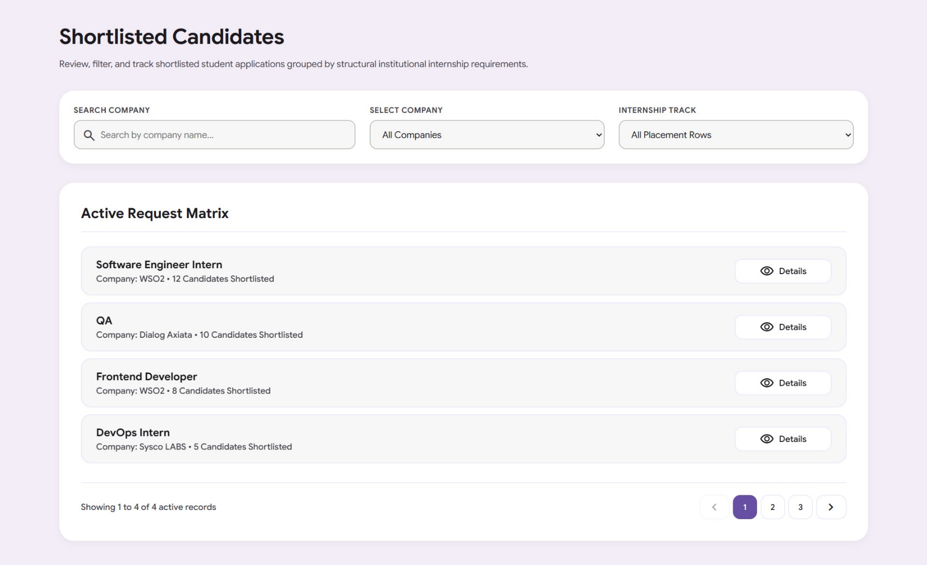

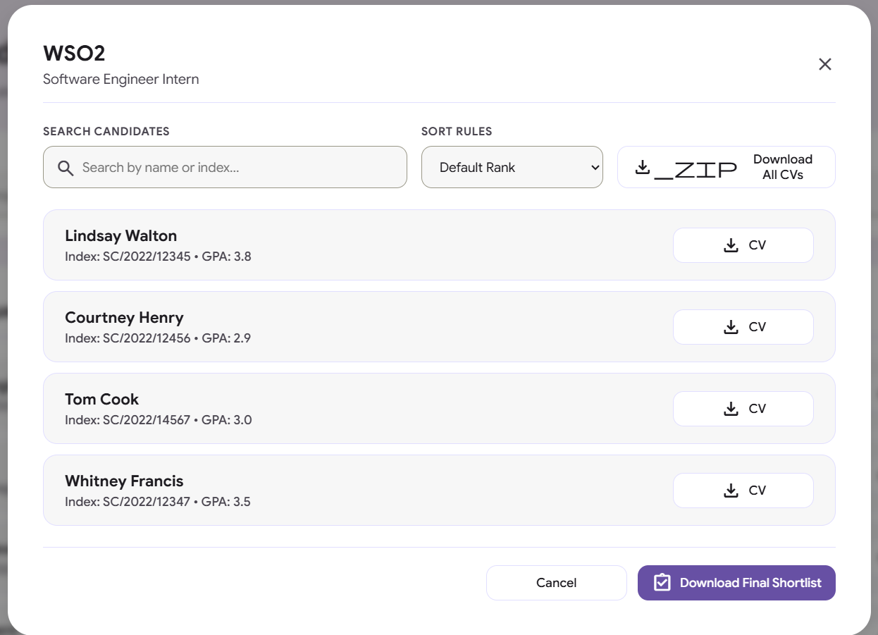

Simple Page Structure Description
- Page Title / Metadata: Configures the administrative dashboard interface under the official browser title "Shortlisted Page" and loads Google Sans typography along with Material Symbols graphics.
- Main Container Wrapper: A primary layout canvas constrained to a maximum centered structure width of 1340px to maintain alignment balance across wide-screen desktop displays.
- Page Header Block: An introductory workspace section housing a bold main header reading "Shortlisted Candidates" and an explanatory sub-paragraph outlining application review and tracking rules.
- Search & Selection Toolbar Row: A layout section grouping sorting and filtering components together within a grid, containing:
  - A text search field labeled "Search Company" embedded with a magnifying search vector icon to lookup records by title.
  - A dropdown select menu labeled "Select Company" featuring tracking paths for All Companies, WSO2, Dialog Axiata, and Sysco LABS.
  - An internship placement track dropdown select menu labeled "Internship Track" hosting sorting paths such as Software Engineer Intern, QA, Frontend Developer, and DevOps Intern.
- Active Request Card Section: A large white container card housing the active company tracking matrix, comprised of:
  - A section title header identifying the collection panel as the "Active Request Matrix".
  - A data row list container populating current requirement modules, each detailing role contexts, company names, cumulative candidate counts, and an interactive "Details" view action trigger button.
- Basal Pagination Control Wrapper: A baseline card section footer displaying active progress details ("Showing 1 to 4 of 4 active records") next to navigation elements framing page indicator index tiles between left and right chevron icons.
- Shortlist Details Modal Overlay: A hardware-accelerated popup dialog window launched via row actions to inspect granular shortlist data, comprising:
  - A header zone dynamically displaying selected company and role titles next to an upper-right close icon handle.
  - A secondary horizontal form toolbar grouping a candidate keyword search bar, a GPA sort rules dropdown menu (Default Rank, High to Low, Low to High), and a functional action button labeled "Download All CVs".
  - A dense rows container compiling individual student rows with Full Names, unique student index codes, hard-locked GPA scores, and custom "CV" document download action buttons.
  - A bottom modal action footer row bundling an inline cancel trigger next to a primary filled button labeled "Download Final Shortlist".
- Notification Popup Window Modal: A high-priority standalone confirmation overlay designed to overlay base modals for system actions, featuring a central circle icon box, a system action heading, a dynamic notification description paragraph, and a wide action button labeled "Acknowledge".

What functionalities that admin can do in this page.
1. Main Matrix Searching & Filtering
- Search by Company Text: The admin can look up specific requirements by typing a company name into the designated text input bar.
- Filter by Select Company: The admin can filter active tracks to isolate specific corporate portfolios using a dropdown selection menu (options include WSO2, Dialog Axiata, and Sysco LABS).
- Filter by Internship Track: The admin can filter row items based on the specific job category from a dedicated dropdown menu (options include Software Engineer Intern, QA, Frontend Developer, and DevOps Intern).
- Navigate Paginated Batches: The admin can look through multiple rows of records using standard pagination navigation buttons, including previous, next, and explicit page index selectors.
2. Request Details Auditing (Modal Overlay)
- Launch Shortlist Profiles: Clicking the row-level "Details" action button next to an active request opens a dedicated modal window displaying detailed candidate statistics for that corporate track.
- Search Specific Candidates: Within the detailed overlay view, the admin can look up specific applicants by typing their name or student index number into an inline text search bar.
- Sort Candidates by Rank: The admin can reorder the candidate directory within the modal by toggling GPA sorting parameters (options include default rank, descending order from High to Low, and ascending order from Low to High).
3. File Exports & Document Downloading
- Bulk Compile CV Archives: Clicking the "Download All CVs" toolbar button inside the details modal triggers a system action to compile and download the full profile document stream as a single package.
- Download Individual Candidate Resumes: Clicking the "CV" action button next to a student's row within the list view triggers a dedicated download for that specific candidate's ATS-compliant PDF file.
- Export Final Shortlists: The admin can click the primary "Download Final Shortlist" filled button in the modal footer to export a completely verified student spreadsheet data payload.
4. System Feedback & Navigation Utilities
- Acknowledge System Statuses: When download or compilation events are triggered, a secondary popup window modal ("System Action") displays to show status descriptions, which the admin can close by clicking an "Acknowledge" button.
- Dismiss Modal Windows: The admin can safely cancel or exit any active modal overlay by clicking the footer cancel button, tapping the top-right close handle cross, clicking outside on the dimmed exterior background mask, or hitting the hardware Escape key.

Simple Page Structure Description
- Page Title / Metadata: Configures the administrative dashboard interface under the official browser title "Shortlisted Page" and loads Google Sans typography along with Material Symbols graphics.
- Main Container Wrapper: A primary layout canvas constrained to a maximum centered structure width of 1340px to maintain alignment balance across wide-screen desktop displays.
- Page Header Block: An introductory workspace section housing a bold main header reading "Shortlisted Candidates" and an explanatory sub-paragraph outlining application review and tracking rules.
- Search & Selection Toolbar Row: A layout section grouping sorting and filtering components together within a grid, containing:
  - A text search field labeled "Search Company" embedded with a magnifying search vector icon to lookup records by title.
  - A dropdown select menu labeled "Select Company" featuring tracking paths for All Companies, WSO2, Dialog Axiata, and Sysco LABS.
  - An internship placement track dropdown select menu labeled "Internship Track" hosting sorting paths such as Software Engineer Intern, QA, Frontend Developer, and DevOps Intern.
- Active Request Card Section: A large white container card housing the active company tracking matrix, comprised of:
  - A section title header identifying the collection panel as the "Active Request Matrix".
  - A data row list container populating current requirement modules, each detailing role contexts, company names, cumulative candidate counts, and an interactive "Details" view action trigger button.
- Basal Pagination Control Wrapper: A baseline card section footer displaying active progress details ("Showing 1 to 4 of 4 active records") next to navigation elements framing page indicator index tiles between left and right chevron icons.
- Shortlist Details Modal Overlay: A hardware-accelerated popup dialog window launched via row actions to inspect granular shortlist data, comprising:
  - A header zone dynamically displaying selected company and role titles next to an upper-right close icon handle.
  - A secondary horizontal form toolbar grouping a candidate keyword search bar, a GPA sort rules dropdown menu (Default Rank, High to Low, Low to High), and a functional action button labeled "Download All CVs".
  - A dense rows container compiling individual student rows with Full Names, unique student index codes, hard-locked GPA scores, and custom "CV" document download action buttons.
  - A bottom modal action footer row bundling an inline cancel trigger next to a primary filled button labeled "Download Final Shortlist".
- Notification Popup Window Modal: A high-priority standalone confirmation overlay designed to overlay base modals for system actions, featuring a central circle icon box, a system action heading, a dynamic notification description paragraph, and a wide action button labeled "Acknowledge".

